Jesse Kim

11/13/2022

UW PCE – IT FDN 110

Assignment 05

Assignment 5 - CD Inventory

## Introduction

This week’s lesson and modules covered more about lists, dictionaries, and writing data to files. We also learned about different methods that can be applied to lists and dictionaries as well as how to try and separate out your code blocks before you start writing it.

## Assignment 4

This week’s assignment rehashed last week’s work where we created a script to allow a user to access and edit a list of stored compact discs (CDs), presumably owned by an organization or group. As “new” CDs are collected, they should be added into the system so the script should include the options to add as well as save the inputs to a text or csv file.

### Creating the program

As most of my code had already been written or filled in via the starter code I proceeded to edit the TODO sections within that file.

### Modifying the Code

I first went through and updated the areas where I would be using dictionaries to store the inputs starting with the declared variables then going through and noting where I would have to iterate through the list of dictionaries.

### Loading the Existing Data

I leveraged the class example code and module lesson to open the file in read-mode then iterate through the values stored in each row to split them into where they would need to be stored according to the dictionary key-values. Then appending them by row to the list.

### Deleting Values

While I used the methods and examples from this week’s module lesson to write code to look compare the value of a key-value pair to the ID specified by a user, I honestly wasn’t able to get this to work and suspected it had something to do with previous troubles where I had issues with dictionaries recognizing integers as values.

When I tried an alternative to remove the ID as a necessary field I did actually get the delete function to work but felt like that wasn’t in the spirit of the assignment. I’m hoping we can cover the step to get this to work correctly in the next session or perhaps I’ll review the work of my peers to get a better understanding of how to write this part.

### Testing

On occasion, I did run into an issue where the ‘saved’ values would only show the keys and not the corresponding value pairs but this would typically resolve after deleting the files and restarting the window.

#### *Loading the previously added albums in VS Terminal*

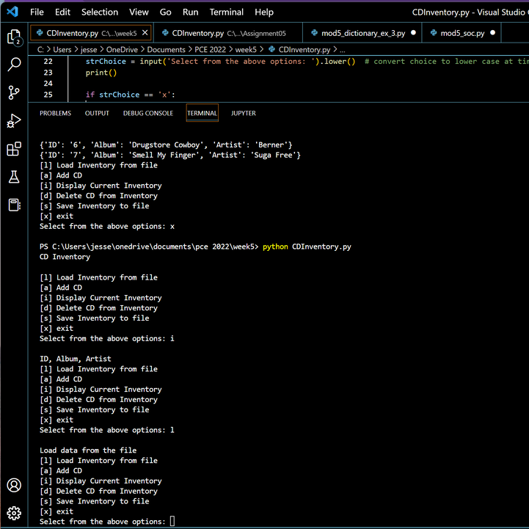

#### *Pulling them up via Display option, then saving*

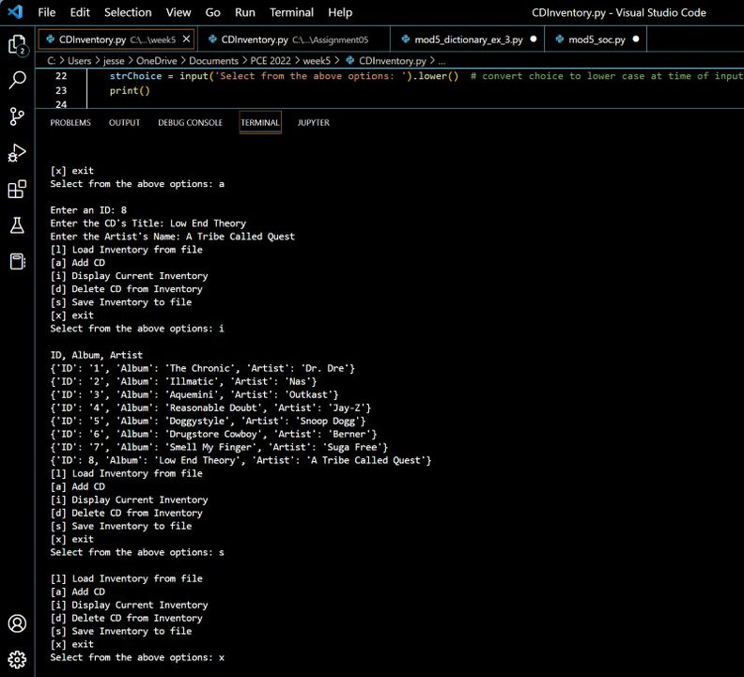

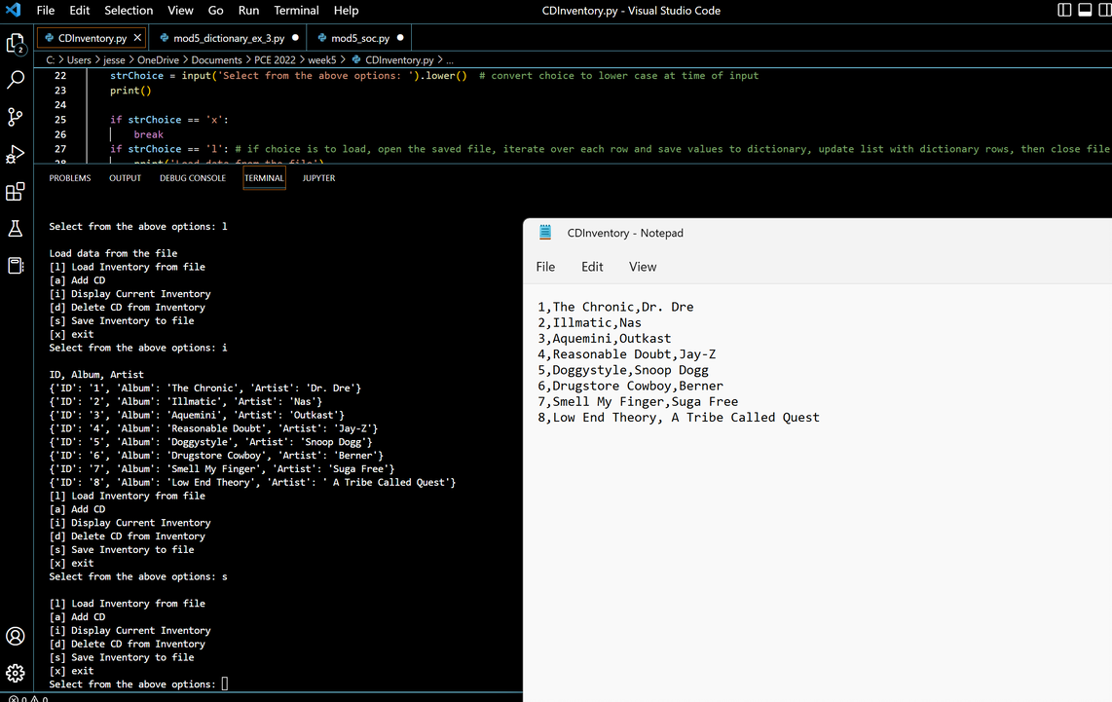

## Summary

This was also a fairly difficult exercise. I almost find it better to start from scratch and almost scrapped everything halfway to toggle to my code from the previous week, but I wanted to try and see what it would be like to work from code that had already been started by another person. I assume that is how most dev projects in the workplace, or otherwise, actually work out. Again, some of the issues encountered in this exercise weren’t easily resolved by reviewing the module or other course materials and that can be a little frustrating. While it’s not uncommon for people to use online resources like Stack Overflow or other similar sites, those are not always applicable solutions and I ended up using a lot of time this week to research solutions. There’s got to be a better way to represent this material for students without giving us the answer outright but that can be quite difficult when teaching this particular subject.